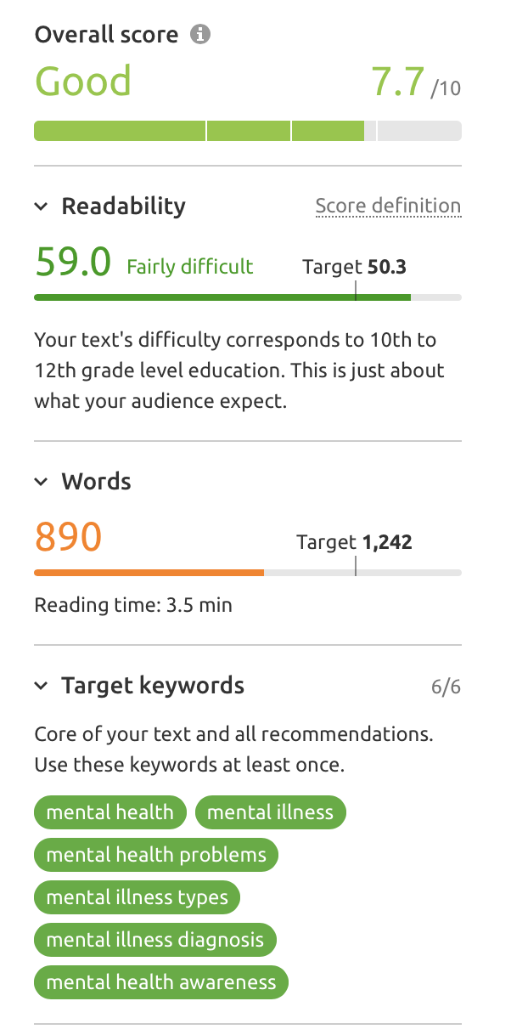 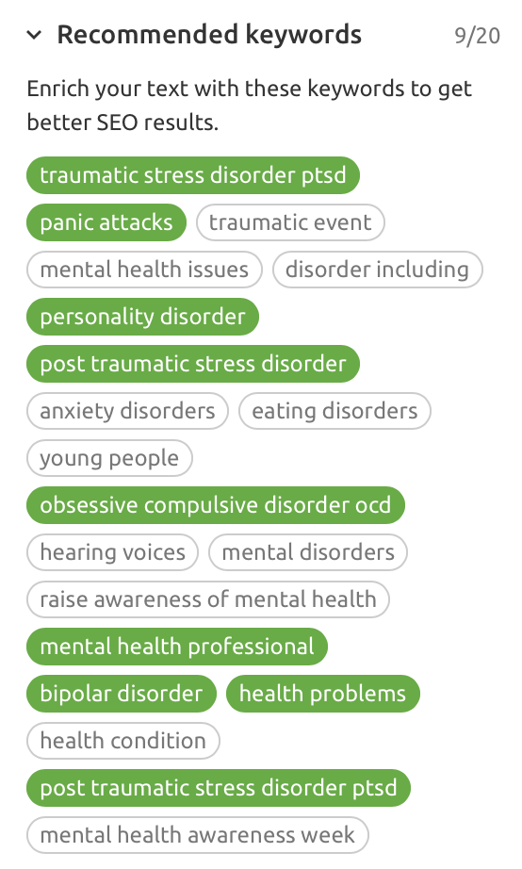

*Top search term is Mental Health – 65,000 searches*

*After this Mental illness rates significantly higher than mental health illness or any other mental health term.*

*Mental Health (60,500 – 61%)*

*Mental Illness (9,900 – 77%)*

*Mental health problems (1,900 – 84%)*

*Mental illness types (1,300 - 85%)*

*Mental illness diagnosis (210 - 82%)*

*Mental health awareness (110 - 84%)*

**MENTAL HEALTH**

One in four adults and one in 10 children in the UK will at some time experience mental health problems. This is more people than those affected by cancer or heart disease, yet is spoken about the least.

Our experienced team of caring and compassionate Support Workers can offer help and support at a time when you need it most. Our team are trained in how to manage the challenging behaviours that can be associated with mental illness in order to effectively support you.

We recognise that mental health is fragile and ever-changing, and that every case of mental illness is different – we totally understand that. We know that what works today may not necessarily work tomorrow and what works for one person may not work for another, that is why our Support Workers are adaptable and ready at short notice to offer help and support when needed in a way that benefits you the most.

Our Mental Health Team can support with personal care, assistance with getting up and going to bed, help with housekeeping and cleaning, managing challenging behaviours and even help through the night when you may feel most vulnerable. Our specialist Mental Health Team can support a wide range of conditions, including Post-Traumatic Stress Disorder, ADHD, autism, epilepsy and many others.

If you or someone you care for is suffering with a mental illness we would like to hear from you to discuss how we can provide support through a dedicated Metal Health Support Plan. Mental health should not be hidden away, we are ready to talk if you are.

**MENTAL HEALTH AWARENESS**

When suffering from mental health problems, sometimes the stigma and feelings of shame can feel as bad as the illness itself. People talk about physical illnesses all of the time, yet still seem to shy away from speaking about mental illness, despite the fact 1 in 4 people will experience mental health problems in their lifetime.

Often, people say they are fine when they are not. If you notice that a family member, friend, colleague or acquaintance is acting differently, it is ok to check twice. If you think there may be something wrong, don’t be sacred to ask twice if they are ok to make sure, often it is the second time that you ask that someone will open up to you.

Make sure you are ‘Mental Health Aware’. There are ‘signs’ that you can look out for that may be an indicator of a deeper mental health problem. Signs to watch out for include, but are not limited to, erratic thought patterns, unexplained changes in mood, a lack of interest in socialising, a lack of empathy, the inability to tell the difference between reality and fantasy, or a lack of control.

If you are concerned about your mental health or that of someone else, you could try taking the NHS [mood assessment quiz](https://www.nhs.uk/conditions/stress-anxiety-depression/mood-self-assessment/). While this will not give a mental illness diagnosis, it could help you to better understand your feelings.

**MENTAL ILLNESS DIAGNOSIS**

There are many mental health problems with a wide range of symptoms that can affect people in different ways. Some people can also effectively ‘hide’ their symptoms form their family and friends, so diagnosis is often extremely difficult. A common ‘symptom’ of mental illness is a change in someone’s personality, thought processes and social life.

There is no one cause for a mental health illness. They can be caused by a wide range of factors, including biological, psychological and environmental. Sometimes, people who already have a family history of mental illness may be more prone to developing mental health problems at some point in their life.

Only a certified mental health professional can provide a diagnosis. If you think that you or someone you know may have a mental illness it is important to speak to a GP as soon as possible.

**MENTAL ILLNESS TYPES**

Here is an overview of some of the most common types of Mental Illness:

* Anxiety and panic attacks
* Bipolar disorder
* Borderline personality disorder
* Depression
* Dissociative disorders
* Hypomania and mania
* Obsessive Compulsive Disorder (OCD)
* Paranoia
* Personality Disorders
* Post-Traumatic Stress Disorder (PTSD)
* Psychosis
* Schizoaffective Disorder
* Schizophrenia
* Self-harm
* Suicidal feelings

**LIVING WITH A MENTAL ILLNESS**

Living with a mental illness can affect many aspects of daily life. It not only has a big impact on your mental health, it can also affect your physical health, relationships, social life, ability to manage money, or your job.

It is not uncommon for people living with mental health problems to feel isolated from their colleagues, friends, and even their family. This can lead to feelings of anger, sadness, fear, helplessness and self-harm. In the most severe cases, mental illness can cause a person to commit suicide.

It is therefore important for those suffering from mental health problems to be supported in the right way so that they do not feel alone. This could be support from family, friends and colleagues., or through professional services.

Seeking help is often the first step towards feeling more positive and staying well, but it can be hard to know how to start or who to turn to. It's common to feel unsure and to think that you should try to handle things on your own. But remember, it is always ok to ask for help.

**MENTAL HEALTH CRISIS**

A mental health crisis usually means that you feel you are unable to cope or that you are not in control of the situation. Common feelings may include:

* Emotional distress
* Extreme anxiety
* Thoughts of suicide,
* The urge to self-harm
* Hallucinations or hearing voices

A crisis can also be the result of an underlying medical condition. For example, confusion or delusions could be caused by an infection, overdose, illicit drugs or intoxication from alcohol. Confusion may also be associated with dementia.

Whatever the cause of the mental health crisis, whether it is a sudden deterioration of an existing heath condition, or symptoms you have not experienced before, it is important to seek help as quickly as possible.

If you are already under the care of a mental health team, follow your crisis plan and if you have a Crisis Line number, call it.

If you are not already under the care of a crisis team there are several options available depending on the severity of the episode:

* The Samaritans operate a free 24/7 service. You can speak to someone in confidence by calling 116 123.
* Contact NHS 111 if you or someone else required urgent but not life-threatening care
* Book an emergency appointment with a GP
* If there is a life-threatening medical or mental health emergency call 999 or got to A&E

**MENTAL HEALTH REFERRALS**

Some mental health services require referrals. You can request a [referral from your GP](https://www.nhs.uk/using-the-nhs/nhs-services/gps/referrals-for-specialist-care/). Other services such as those relating to [drug problems](https://www.nhs.uk/Service-Search/Mental-health-services-for-drug-misuse/LocationSearch/338) and [alcohol problems](https://www.nhs.uk/Service-Search/Mental-health-services-for-alcohol-addiction/LocationSearch/294), allow you to refer yourself.

If your mental health problems are related to stress in your workplace, check out the [Time to Change](https://www.time-to-change.org.uk/get-involved/tackle-stigma-workplace/support-employees) website.

If you are at school or college, mental health care may be arranged for you. You can also find out more about [child and adolescent mental health services](https://www.nhs.uk/using-the-nhs/nhs-services/mental-health-services/child-and-adolescent-mental-health-services-camhs/).